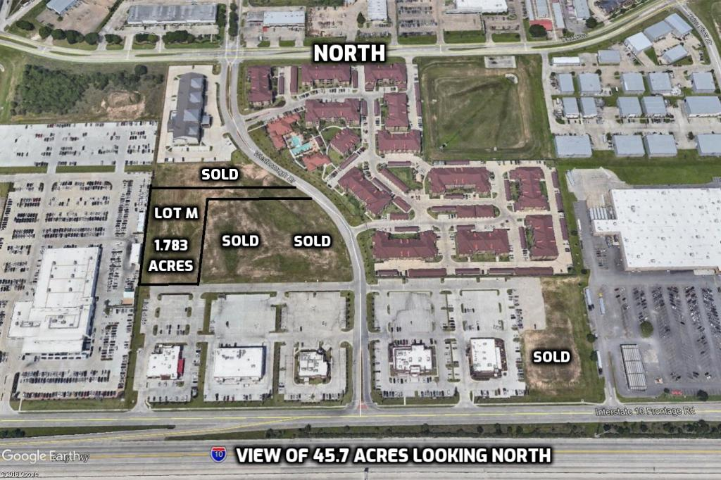
- Developer has constructed the regional detention pond shown on the site plan on the northeast corner of the 45.7 acre tract. On site detention will not be required.
- Developer has constructed all water, sanitary sewer and storm sewer lines to each tract.
- Developer has constructed Westborough Drive per site plan.
- Developer will provide cable, electricity, and gas to each tract.
- Weston MUD will provide wastewater capacity reservation letters based on required amounts for specific uses.
- Developer will approve all signage packages for each tract.
- Developer will provide a Declaration of Covenants for all users that acquire property in this development.
LAST REMAINING AVAILABLE LOT:
Lot M – 1.783 acres – with direct access to Westborough Drive and I-10 Feed Road
PROPERTY TAX INFORMATION – 2021 RATES | %
KATY ISD | 1.35170
HARRIS COUNTY | 0.37693
HARRIS COUNTY FLOOD CONTROL | 0.03349
PORT OF HOUSTON AUTHORITY | 0.00872
HARRIS COUNTY HOSPITAL DISTRICT | 0.16221
HARRIS COUNTY EDUCATION DEPARTMENT | 0.00499
HARRIS COUNTY EMERGENCY SERVICE DISTRICT 47 | 0.08400
WESTON MUD | 0.32000
TOTAL | 2.34204

